The following modifications were based on discussion with David S at ASC this past Friday. For certain areas he did inquire with their top Brand Representative from Titus for confirmation.

I created some example images of below details for ease in understanding in case I was not sufficiently thorough in my text. Please reference pgs 3-4 of doc

For Monday’s review with ASC they would like to see all real data including actual Configuration and pricing.

Attached you will find the updated NCD Product List and an updated Titus spreadsheet.

From the Titus spreadsheet – Column D is the Long Description which should only appear in the Detail Screen

From the NCD spreadsheet – Column D is the Short Description which should only be used for the results Grid Description column. This description includes the dimensions which are most needed at quick glance by the Sales Reps.

From the NCD spreadsheet – Column AA we are being provided actual pricing. They would like for us to use real pricing.

ASC would like for us to separate the Details from the Warehouse pop up window.

The details should be viewable by click on an icon (preferred indicated by an ‘i’) and located before the SKU number on the results grid. They would still prefer to hover over the icon but ASC indicated that if this is not possible then an icon the user must click on is acceptable.

The details/information should only display the SKU, configuration, price, image, and long description.

From the Result grid remove the Configuration string column. The configuration will only be displayed in the details screen.

On the results grid they would like for us to add back the shopping cart image to each line item after the QTY needed. They want to keep the bottom Add to Shopping cart as well. This so the user can add one by one (per row) or order multiple from the grid results and add all to the shopping cart by clicking on the Add To Cart at the bottom of the screen.

On the results grid they would like to add a column for a multiple Warehouse icon that is enabled if the product exists in more than one Warehouse and disabled if it only exists in the default warehouse. In this pop up all they want is to show the right hand side of the current details page – only show the Price, Warehouse information and needed columns and Totals.

We reviewed the In Stock QTY for default warehouse/ In Stock QTY for all warehouse. They do not like this type of design and prefer that we do not have slashes and explanations denoted at the bottom of the screen. If we enable and disable the multi warehouse button then we do not need to show Total stock for all warehouses in the QTY In Stock column; it should only reflect the Default Warehouse.

ASC feels that we can probably shrink some of the columns (like SKU and Model) to give us more room for these additional buttons. And since we are removing the Configuration column we should have more room for the new icons/columns. Based on us using the short description we can probably resize this column as well. If more room is available then extend the default size of the menu tree/search pane on left hand side.

The following request is minor and is not necessary for Monday:

The scroll bar on the results grid – user should be able to click below or above the scroll bar itself and also move the page. That is the user should not have to click on the arrows or drag the scroll bar if they prefer to click below or above the scroll bar.

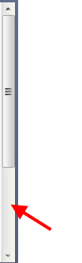

Menu Tree – when user clicks to expand or collapse (+/-) they would like to also automatically populate the results grid. Not just when the user clicks on the title.

Per Friday’s review in-house we remain pending completion of the following areas:

Intuitive Data entry for QTY needed column – we agreed for this to be similar to the Warehouse/Detail screen.

Search functionality - collapse the menu tree as user selects Search button.

Ability to sort by columns
Example Warehouse Image (Add: Details, Add to Cart, Multi Warehouse columns and Remove Configuration column)
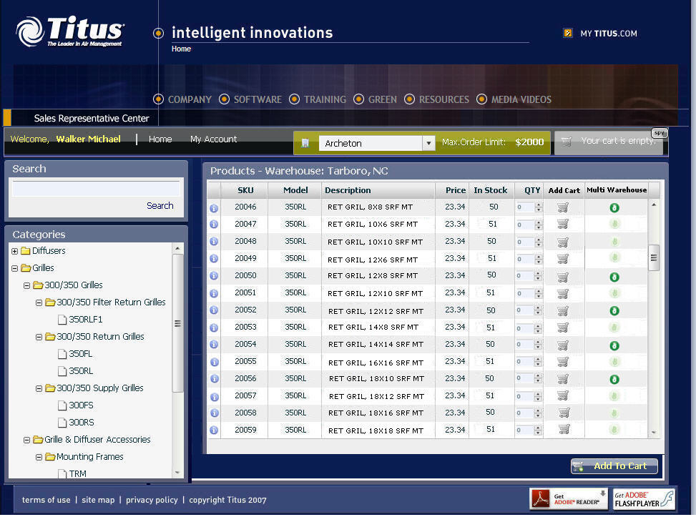
Example Multi Warehouse Example Detail

